# Assignment -2

|  |  |
| --- | --- |
| Assignment Date | 15 September 2022 |
| Student Name | Susanthy U |
| Student Roll Number | 2021T307 |
| Maximum Marks | 2 Marks |

**Question-1:**

1. Create a Flask App
2. Add a Home page, About page
3. Add the Bootstrap
4. Add the Sign in page and Signup page

# Solution :

**HTML :**

# Home page :

<!doctype html>

<html lang="en">

<head>

<meta charset="UTF-8">

<meta name="viewport"

content="width=device-width, user-scalable=no, initial-scale=1.0, maximum-scale=1.0, minimum-scale=1.0">

<meta http-equiv="X-UA-Compatible" content="ie=edge">

<title>Homepage</title>

<link rel="stylesheet" href="{{ url_for('static',filename='css/homepage.css') }}" />

</head>

<body>

<div class="banner-area">

<div class="wrapper">

<div class="navigation">

<div class="logo">

</div>

<nav>

<a href="http://127.0.0.1:5000/about" ><BUTTON class="button"><strong>About</strong></BUTTON></a>

<a href="http://127.0.0.1:5000/sign" ><BUTTON class="button"><STRONG>Sign in</STRONG></button></a>

<a href="http://127.0.0.1:5000/sigup" ><button class="button"><STRONG>Sign up</STRONG></button></a>

</nav>

</div>

<div class="banner-text">

<div class="text-area">

<h3 class="new">Welcome to My New Project</h3>

<a href="#" >Dashboard</a>

</div>

</div>

</div>

</div>

</body>

</html>

# About page :

<!doctype html>

<html lang="en">

<head>

<meta charset="UTF-8">

<meta name="viewport"

content="width=device-width, user-scalable=no, initial-scale=1.0, maximum-scale=1.0, minimum-scale=1.0">

<meta http-equiv="X-UA-Compatible" content="ie=edge">

<title>aboutPage</title>

<link rel="stylesheet" href="{{ url_for('static',filename='css/about.css') }}" />

</head>

<body>

<div class="about-section">

<h2>About Us Page</h2>

<p>Hi All I am Saravanan , I created this page for my college naliyathiran project and it is helpful to improve our Knowledge</p>

<p></p>

</div>

<h2 style="text-align:center">Thank You</h2>

</body>

</html>

# Signin page :

<!doctype html>

<html lang="en">

<head>

<meta charset="UTF-8">

<meta name="viewport"

content="width=device-width, user-scalable=no, initial-scale=1.0, maximum-scale=1.0, minimum-scale=1.0">

<meta http-equiv="X-UA-Compatible" content="ie=edge">

<title>Sign in</title>

<link rel="stylesheet" href="{{ url_for('static',filename='css/sign.css') }}" />

</head>

<body>

<form>

<div class="container">

<label for="uname"><b>Username</b></label>

<input type="text" placeholder="Enter Username" name="uname" required>

<label for="psw"><b>Password</b></label>

<input type="password" placeholder="Enter Password" name="psw" required>

<button type="submit">Login</button>

<label>

<input type="checkbox" checked="checked" name="remember"> Remind me

</label>

</div>

<div class="container" style="background-color:#f1f1f1">

<button type="button" class="cancelbtn">Cancel</button>

<span class="psw">Forgot <a href="#">password?</a></span>

</div>

</form>

</body>

</html>

# Signup page :

<!doctype html>

<html lang="en">

<head>

<meta charset="UTF-8">

<meta name="viewport"

content="width=device-width, user-scalable=no, initial-scale=1.0, maximum-scale=1.0, minimum-scale=1.0">

<meta http-equiv="X-UA-Compatible" content="ie=edge">

<title>Sign up</title>

<link rel="stylesheet" href="{{ url_for('static',filename='css/signup.css') }}" />

</head>

<body>

<form style="border:1px solid #ccc">

<div class="container">

<h1>Sign Up</h1>

<p>Please fill in this form to create an account.</p>

<hr>

<label for="email"><b>Email</b></label>

<input type="text" placeholder="Enter Email" name="email" required>

<label for="psw"><b>Password</b></label>

<input type="password" placeholder="Enter Password" name="psw" required>

<label for="psw-repeat"><b>Repeat Password</b></label>

<input type="password" placeholder="Repeat Password" name="psw-repeat" required>

<label>

<input type="checkbox" checked="checked" name="remember" style="margin- bottom:15px"> Remind me

</label>

<p>By creating an account you agree to our <a href="#" style="color:red">Terms & Privacy</a>.</p>

<div class="clearfix">

<button type="button" class="cancelbtn">Cancel</button>

<button type="submit" class="signupbtn">Sign Up</button>

</div>

</div>

</form>

</body>

</html>

# CSS :

**Home page :**

*{

margin: 0;

padding: 0;

}

body{

font-family:"Times New Roman";

}

.wrapper{

width: 1170px; margin: 0 auto;

}

.logo{

width: 20%; float: left;

padding: 30px 0 0; font-size: 25px; font-weight: 700; color: #fff;

}

nav{

width: 75%; float: right;

text-align: right; padding: 30px 0 0;

}

nav a{

text-decoration: none; color: #fff;

padding: 15px 20px;

}

.navigation{ height: 60px;

}

.banner-area{

animation-name: animate; animation-duration: 7s;

animation-iteration-count: infinite; animation-timing-function: ease-in-out; height: 100vh;

}

.text-area{

text-align: center; width: 75%;

margin: 0 auto;

}

.text-area h2{ font-size: 75px; color: #fff;

margin: 10% 0 0;

}

.text-area h3{ color: #fff;

text-transform: uppercase; margin: 0 0 15px;

font-size: 35px;

}

.text-area a{

text-decoration: none; background: white; color: deeppink; padding: 15px 60px; font-size: 18px; display: inline-block; margin-top: 5%; border-radius: 50px;

}

.text-area p{

font-size: 18px; color: #fff; width: 70%;

margin: 0 auto; line-height:1.9;

}

@keyframes animate { 0%{

background: brown;

} 25%{

background: blueviolet;

} 50%{

background: blueviolet;

} 75%{

background: blueviolet;

} 100%{

background: blueviolet;

}

}

/* ignore the code below */

.link-area

{

position:fixed; bottom:20px; left:20px; padding:15px; border-radius:40px; background:tomato;

}

.link-area a

{

text-decoration:none; color:#fff;

}

.button{

color: darkgoldenrod; background-color: white; border-radius:12px ; padding-left: 5px; padding-right: 5px; padding-top: 5px; padding-bottom: 5px; border: none;

}

.new{

padding:50px ; padding-left: 50px;

}

# About page :

body {

font-family: Arial, Helvetica, sans-serif; margin: 0;

}

html {

box-sizing: border-box;

}

*, *:before, *:after { box-sizing: inherit;

}

.column { float: left;

width: 33.3%;

margin-bottom: 16px; padding: 0 8px;

}

.card {

box-shadow: 0 4px 8px 0 rgba(1, 0.5, 0.7, 0.2); margin: 8px;

}

.about-section { padding: 50px; text-align: center;

background-color: darkred; color: lavender;

}

.container { padding: 0 16px;

}

.container::after, .row::after { content: "";

clear: both; display: table;

}

.title {

color: hotpink;

}

.button { border: none; outline: 0;

display: inline-block; padding: 8px;

color: red;

background-color: #000; text-align: center; cursor: pointer;

width: 100%;

}

.button:hover { background-color: #555;

}

@media screen and (max-width: 650px) {

.column { width: 100%;

display: block;

}

}

# Signin page :

form {

border: 3px solid #f1f1f1;

}

/* Full-width inputs */

input[type=text], input[type=password] { width: 100%;

padding: 12px 20px; margin: 10px 0; display: inline-block; border: 2px solid #ccc; box-sizing: border-box;

}

/* Set a style for all buttons */ button {

background-color: gray; color: blue;

padding: 14px 20px; margin: 8px 0;

border: none; cursor: pointer; width: 100%;

}

/* Add a hover effect for buttons */ button:hover {

opacity: 0.8;

}

/* Extra style for the cancel button (red) */

.cancelbtn { width: auto;

padding: 10px 18px; background-color: orange;

}

/* Center the avatar image inside this container */

.imgcontainer {

text-align: center; margin: 24px 0 12px 0;

}

/* Avatar image */ img.avatar {

width: 40%;

border-radius: 50%;

}

/* Add padding to containers */

.container { padding: 16px;

background-color: lightsteelblue;

}

/* The "Forgot password" text */ span.psw {

float: right; padding-top: 16px;

}

/* Change styles for span and cancel button on extra small screens */ @media screen and (max-width: 300px) {

span.psw { display: block; float: none;

}

.cancelbtn {

width: 100%;

}

}

# Signup page :

* {box-sizing: border-box}

/* Full-width input fields */ input[type=text], input[type=password] {

width: 100%; padding: 5px;

margin: 5px 0 20px 0;s display: inline-block; border: none; background: #f1f1f1;

}

input[type=text]:focus, input[type=password]:focus { background-color: #ddd;

outline: none;

}

hr {

border: 1px solid #f1f1f1; margin-bottom: 25px;

}

/* Set a style for all buttons */ button {

background-color: #04AA6D; color: white;

padding: 14px 20px; margin: 8px 0; border: none; cursor: pointer; width: 100%;

opacity: 0.9;

}

button:hover { opacity:1;

}

/* Extra styles for the cancel button */

.cancelbtn {

padding: 14px 20px; background-color: #f44336;

}

/* Float cancel and signup buttons and add an equal width */

.cancelbtn, .signupbtn { float: left;

width: 50%;

}

/* Add padding to container elements */

.container { padding: 16px;

background-color: lightskyblue;

}

/* Clear floats */

.clearfix::after { content: ""; clear: both; display: table;

}

/* Change styles for cancel button and signup button on extra small screens */ @media screen and (max-width: 300px) {

.cancelbtn, .signupbtn { width: 100%;

}

}

# Python Flask (app.py)

from flask import Flask,render_template wep = Flask( name )

@wep.route('/')

def a(): # put application's code here

return render_template('html/homePage.html')

@wep.route('/about')

def b(): # put application's code here

return render_template('html/aboutPage.html')

@wep.route('/sign')

def c(): # put application's code here

return render_template('html/signPage.html')

@wep.route('/sigup')

def d(): # put application's code here

return render_template('html/sigupPage.html')

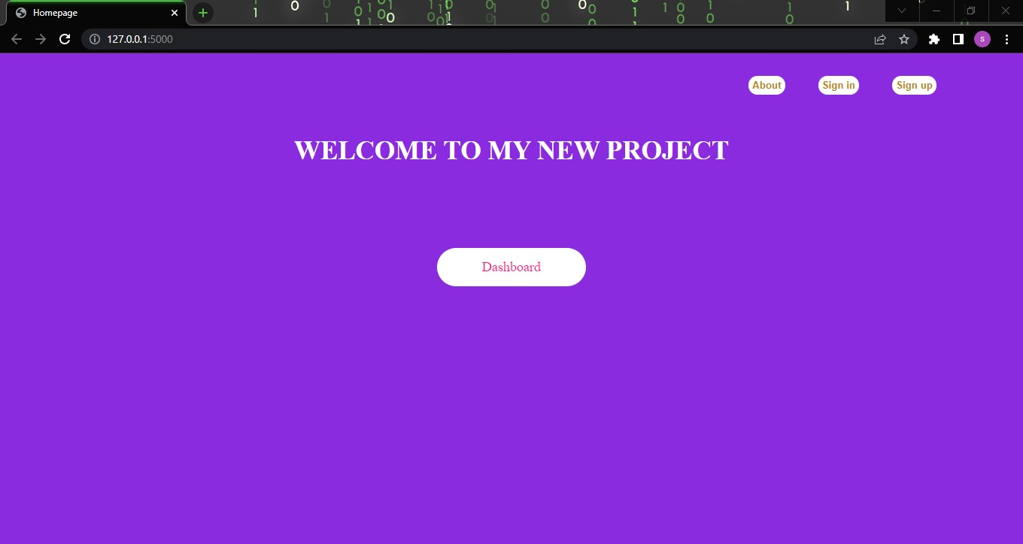

if name == ' main ': wep.run()

# Output :

**Home Page :**

# About Page :

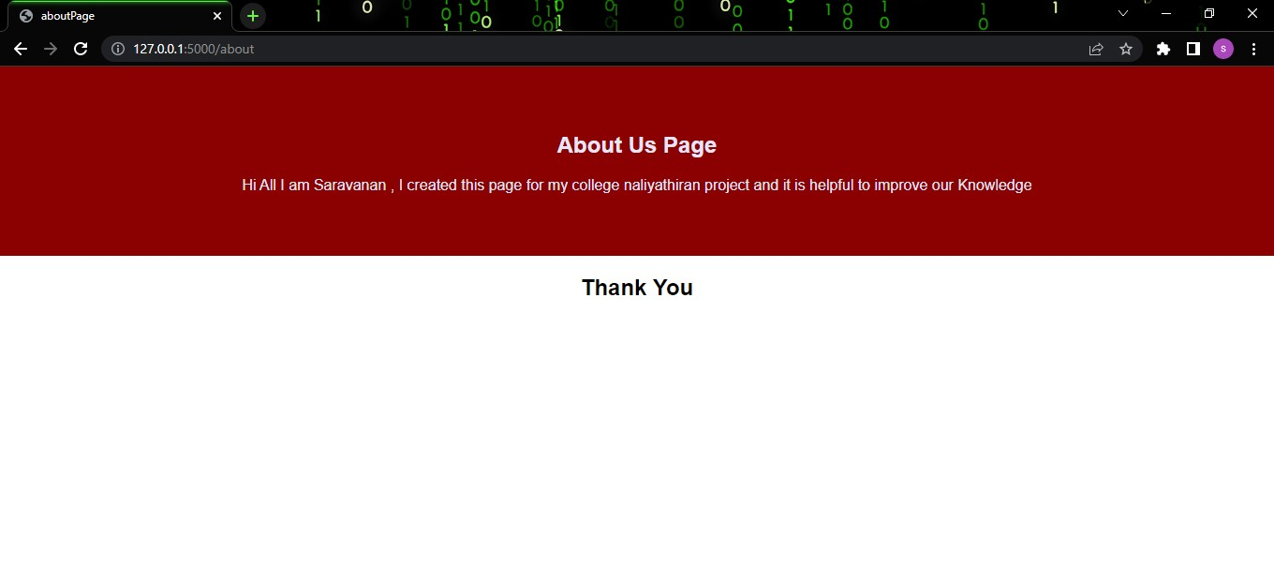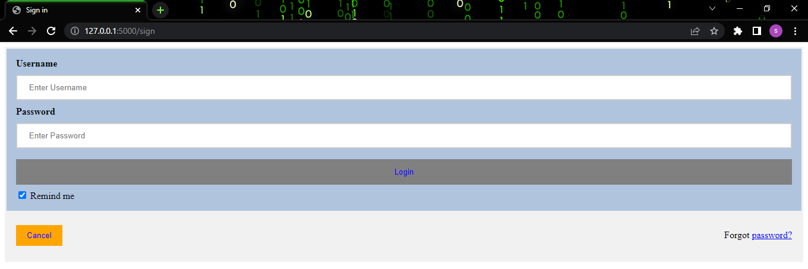

**Signin Page :**

# Signup Page :

